**CHAPTER 1**

**ABOUT THE COMPANY**

* 1. **INTRODUCTION**

KTS is a fast and dynamic software company founded in 2020 in the silicon valley of India at Bangalore with the vision of providing the best services, Training to clients and students. It is a certified software company by the government of India. (Reg.no: KR-03-0010654). Our clients are remarkably diverse: large and small, private and public, for-profit, and nonprofit. We help them grow, sustain, and transform. Our one of the technical teams from multiple MNC companies bind together to help the students to learn Technical concepts at the best level.

K-AKA Technology Services an ISO 9001: 2015 Certified company (Accredited by International Accreditation Services: IAS). The company is highly specialized in the design and development of the website, software application development, mobile application development, E-Commerce solution, and more.

**Vision**

To become the world’s leading Innovative training provider, IT service provider, providing Software Development solutions across the globe.

**Mission**

Design, Deliver Affordable and Quality training By identifying and Developing World Class Learning Platforms and ensure the best quality product and profitable growth through customer service, innovation, and commitment

**1.2 SERVICES**

K-AKA Technology Service offers the services in the following areas:

* SaaS (Software as a service)
* Training and Development
* Software Development

**1.2.1 SaaS (Software as a Service)**

Digitalization in the current world makes small-large business partners manage the work globally at distance. We provide software support to company/organization/government-Non-Government Institute. The support includes web, android, ios platform, need(s) oriented application, etc.

**1.2.2 Training and Development**

Looking at the progress in the corporate world, engineering aspirants of all branches must have coding, application development skills. These skills are looked at by many recruiting companies as a usual parameter irrespective of any branches.

Thus, we organize a workshop, training, internship across engineering/non-engineering colleges which remarkably diverse: Large duration and small duration program. We make our students experts in the selected domain to the best extent and compete with the corporate world.

**1.2.3 Software Development**

We mainly focus on the following areas of software development:

* Enterprise Application Services
* Web designing and Development
* Mobile Application development
  1. **TEAM**

K-AKA Technology Services is a team of experienced professionals providing a wide range of complex software and web application development services. professional with vast experience who are working in MNC, IT Industry, Multiple technologies.

Our technical team focused on providing the best training to the engineers to land into the corporate world. The company started with the vision of adding value in the private/public, small/large organization with the service to the best extent. The company tied with multiple colleges across Karnataka to organize the certification courses and the corporate technical training to help the student to fill the bridge between the corporate and the college.

**CHAPTER 2**

**ABOUT THE DEPARTMENT**

Our technical team focused on providing the best training to the engineers to land into the corporate world. The company started with the vision of adding value in the private/public, small/large organization with the service to the best extent. The company tied with multiple colleges across Karnataka to organize the certification courses and the corporate technical training to help the student to fill the bridge between the corporate and the college.

**2.1 SOFTWARE DEVELOPMENT DEPARTMENT**

The software development Process organizes practical procedures and approaches in application development. K-AKA Technology Service wants to streamline their internal departments and functions, operations, sale and project management, etc. and want to take the advantage of a web-based application, flexibility by moving away from the traditional desktop application platform to the web application platform and want to gain more client for better services their current clients offering convenient services and solutions online to build a new web application to offer innovative services or solutions to online user and business.

**2.1.1 Duties**

Software Developers typically do the following:

* Explore fundamental issues in computing and develop theories and models to address those issues.
* Help scientists and engineers solve complex computing problems.
* Invent new computing languages, tools, and methods to improve how people work with computers.
* Develop and improve the software systems that form the basis of the modern computing experience.
* Design experiments to test the operation of these software systems.
* Analyze the results of their experiments.
* Publish their findings in academic journals.

**2.2 PROCESS STRUCTURE**

The following figure and list of procedures and documents provide a good outline for Lifecycle and Process:

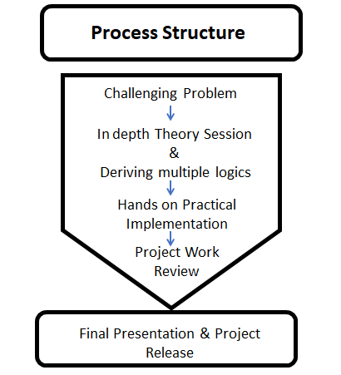**Fig2.2:**Processstructure

**1. Challenging Problem: software developers**improve computer algorithms, which are sets of instructions that tell a computer what to do. Some computer tasks are very difficult and require complex algorithms. They try to simplify these algorithms to make computer systems as efficient as possible. These algorithms allow advancements in many types of technology, such as machine learning systems and cloud computing.

**2. In-depth Theory Session and Deriving Multiple Logics:**The work often leads to technological advancements and efficiencies, such as better networking technology, faster computing speeds, and improved information security, and deriving multiple logic for the given problem statement. In general, computer and information research scientists work on a more theoretical level than do other computer professionals.

**3. Hands-on Practical Implementation:**Computer and information research scientists design new programming languages that are used to write software. The new languages make software writing more efficient by improving an existing language, such as Java, or by making a specific aspect of programming, such as image processing, easier.

4. **Project work review:**A Project Work Review is an exercise undertaken at the end of each Project Phase to identify the current status of the project. The Project Review identifies the deliverables which have been produced to date and determine whether or not the project has met the objectives set.

5. **Final Presentation and Project Release:** The term release is used to define when a project deliverable is complete and ready for delivery to the project customer, either internally (to manufacturing or operations, for example) or to an external company or individual.

**2.3 SOFTWARE DEVELOPMENT PROCESS**

The following list of the procedures and documents provide a good outline for the software development and process:

· Roadmap document: Defining application, process, goal, and direction

· Researching and Defining Audience scope and security documents

· Creating Functional Specification or Feature Summary Documents

· Team Collaboration and project management document

· Application Visual Guide, design layout, interface design, wire framing

**CHAPTER 3**

**INTRODUCTION**

* 1. **TASK PERFORMED**

**Technologies Used**

* Web Module
* HTML
* CSS
* Java Scripts
  + 1. **HTML**

**Hypertext Markup Language** (**HTML**) is the standard markup language for documents designed to be displayed in a web browser. It can be assisted by technologies such as Cascading Style Sheets (CSS) and scripting languages such as JavaScript. Web browsers receive HTML documents from a web server or from local storage and render the documents into multimedia web pages. HTML describes the structure of a web page semantically and originally included cues for the appearance of the document. HTML elements are the building blocks of HTML pages. With HTML constructs, images and other objects such as interactive forms may be embedded into the rendered page. HTML provides a means to create structured documents by denoting structural semantics for text such as headings, paragraphs, lists, links, quotes and other items. HTML elements are delineated by *tags*, written using angle brackets. Tags such as <**img** /> and <**input** /> directly introduce content into the page. Other tags such as <**p**> surround and provide information about document text and may include other tags as sub-elements. Browsers do not display the HTML tags, but use them to interpret the content of the page.

* + 1. **CSS**

# Cascading Style Sheets (CSS) is a style sheet language used for describing the presentation of a document written in a markup language like HTML. CSS is a cornerstone technology of the World Wide Web, alongside HTML and JavaScript

# This separation can improve content accessibility, provide more flexibility and control in the specification of presentation characteristics, enable multiple web pages to share formatting by specifying the relevant CSS in a separate .css file, and reduce complexity and repetition in the structural content.

# Separation of formatting and content also makes it feasible to present the same markup page in different styles for different rendering methods, such as on-screen, in print, by voice (via speech-based browser or screen reader), and on Braille-based tactile devices. CSS also has rules for alternate formatting if the content is accessed on a mobile device

# Java Scripts

# Alongside HTML and CSS, JavaScript is one of the core technologies of the World Wide Web.JavaScript enables interactive web pages and is an essential part of web applications. Most websites use it for client-side page behavior, and all major web browsers have a dedicated JavaScript engine to execute it. As a multi-paradigm language, JavaScript supports event-driven, functional, and imperative programming styles. It has application programming interfaces (APIs) for working with text, dates, regular expressions, standard data structures, and the Document Object Model (DOM). However, the language itself does not include any input/output (I/O), such as networking, storage, or graphics facilities, as the host environment (usually a web browser) provides those APIs.

JavaScript engines were originally used only in web browsers, but they are now embedded in server-side website deployments, usually via Node.js. They are also in variety of applications created with frameworks such as Electron and Cordova.

* + 1. **Google Scripts**

# Apps Script is a scripting platform developed by Google for light-weight

application development in the G Suite platform. Google Apps Script was initially developed by Mike Harm as a side project whilst working as a developer on Google Sheets. Google Apps Script was first publicly announced in May 2009 when a beta testing program was announced by Jonathan Rochelle, then Product Manager, Google Docs.In August 2009 Google Apps Script was subsequently made available to all Google Apps Premier and Education Edition customers. It is based on JavaScript 1.6, but also includes some portions of 1.7 and 1.8 and a subset of the ECMAScript 5 API. Apps Script projects run server-side on Google's infrastructure. According to Google, Apps Script "provides **e**asy ways to automate tasks across Google products and third-party services."Apps Script is also the tool that powers the add-ons for Google Docs, Sheets and Slide.

# Tools Used:

## List of tools used during internship

* DevC++
* Sublime Text editor
* Bracket
* Firebase

# DevC++

**Dev-C++** is a [free](https://en.wikipedia.org/wiki/Free_software) full-featured [integrated development environment](https://en.wikipedia.org/wiki/Integrated_development_environment) (IDE) distributed under the [GNU General Public License](https://en.wikipedia.org/wiki/GNU_General_Public_License) for programming in [C](https://en.wikipedia.org/wiki/C_(programming_language)) and [C++](https://en.wikipedia.org/wiki/C%2B%2B). It is written in Delphi.

It is bundled with, and uses, the [MinGW](https://en.wikipedia.org/wiki/MinGW)or [TDM-GCC](https://en.wikipedia.org/wiki/TDM-GCC) 64bit port of the [GCC](https://en.wikipedia.org/wiki/GNU_Compiler_Collection) as its compiler. Dev-C++ can also be used in combination with [Cygwin](https://en.wikipedia.org/wiki/Cygwin) or any other GCC-based compiler.[[1]](https://en.wikipedia.org/wiki/Dev-C%2B%2B#cite_note-1)

Dev-C++ is generally considered a [Windows-only](https://en.wikipedia.org/wiki/Microsoft_Windows) program, but there are attempts to create a Linux version: header files and path delimiters are switchable between platforms.

# 

**Fig 3.2:** DevC++ main screen

# Features

* Support GCC based compilers
* Integrated debugging (usingGDB)
* ProjectManager
* Customizable syntax highlightingeditor
* ClassBrowser
* CodeCompletion
* FunctionListing
* ProfilingSupport
* Quickly create Windows, console, static libraries andDLLs
* Support of templates for creating your own projecttypes
* Makefilecreation
* Edit and compile reportfiles
* ToolManager
* Print support
* Find and replace facilities
  + 1. **Sublime Text Editor**

Sublime Text is a [proprietary](https://en.wikipedia.org/wiki/Proprietary_software) [cross-platform](https://en.wikipedia.org/wiki/Cross-platform) [source code editor](https://en.wikipedia.org/wiki/Source_code_editor) with a [Python](https://en.wikipedia.org/wiki/Python_(programming_language)) application programming(API). It natively supports many programming languages and [markup languages,](https://en.wikipedia.org/wiki/Markup_languages) and functions can be added by users with [plugins](https://en.wikipedia.org/wiki/Plugins), typically community-built and maintained under [free-software licenses.](https://en.wikipedia.org/wiki/Free_software_licenses)

# Features

Sublime Text has a number of features in addition to these including:

* Auto-save, which attempts to prevent users from losing their work
* Customiza[ble key assignments](https://en.wikipedia.org/wiki/Keyboard_shortcut), a navigational tool which allows users to assign hotkeys to their choice of options in both the menus and the toolbar
* Find as you type, begins to look for the text being entered as the user types without requiring a separat[e dialog box](https://en.wikipedia.org/wiki/Dialog_box)
* Spell check function corrects as you type
* Macros
* Repeat the last action
* A wide selection of editing commands, including indenting and unindenting, paragraph reformatting and line joining.
  + 1. **Bracket**

A **bracket** is either of two tall fore- or back-facing punctuation marks commonly used to isolate a segment of text or data from its surroundings.

Specific forms of the mark include rounded brackets (also called *parentheses*), square brackets, curly brackets (also called *braces*), and angle brackets (also called *chevrons*), as well as various less common pairs of symbols.

As well as signifying the overall class of punctuation, the word *bracket* is commonly used to refer to a specific form of bracket, which varies from region to region. In North America, an unqualified 'bracket' typically refers to the square bracket; in Britain, the round bracket.

* + 1. **Firebase**

Firebase evolved from Envolve, a prior startup founded by James Tamplin and Andrew Lee in2011. Envolve provided developers an API that enables the integration of online chat

functionality into their websites. After releasing the chat service, Tamplin and Lee found that it was being used to pass application data that were not chatting messages. Developers were using Envolve to sync application data such as the game state in real-time across their user Tamplinand Lee decided to separate the chat system and the real-time architecture that

powered it. They founded Firebase as a separate company in September 2011 and it launched to the public in April 2012.

**Features:**

#### Firebase Cloud Messaging

#### Firebase Authentication

#### Firebase Real-time Database

#### Cloud Fire store

#### Firebase Storage

* Firebase Hosting

Firebase Authentication is a service that can authenticate users using only client-side code. It supports social login providers Facebook, GitHub, Twitter, and Google as well as other

service providers like Google Play Games, Apple, Yahoo, and Microsoft.

Additionally, it Includes a user management system whereby developers can enable user authentication with email and password login stored with Firebase. Firebase provides a Realtime database and backend as a service. The service provides application developers an API that allows application data to be synchronized across clients and stored on Firebase's cloud.

**CHAPTER 4**

**REQUIREMENT SPECIFICATION**

**4.1 SOFTWARE REQUIREMENTS**

* Operating System : Windows 7 and above.
* Programming Language : JavaScript’s
* Environment (Libraries and Technologies) : Sublime IDLE
* Backend server : Firebase
* Front-end Technologies : HTML , CSS

**4.2 HARDWARE REQUIREMENTS**

* Processor : Intel Dual Core CPU.
* Processor Speed : 1.7 GHz.
* RAM : 4 GB.
* System Type : 64-Bit Operating System.
* Input Devices : Keyboard, Mouse.

**CHAPTER 5**

**IMPLEMENTATION**

* Once after registering for the exam, the candidate can take up MCQ exam.
* After taking up MCQ platform, only if the average marks or qualifying marks is scored by the candidate, he/she can take up SBQ exam.
* Both for MCQ and SBQ exam timer will be set
* Until the candidate takes up MCQ exam, he/she cannot take up SBQ exam
* Registration Can be done only if the user is logged into the Exam Dashboard. If the user is not Registered he/she can create an new account and Verify there email and only then can be logged into the Dashboard
* Exam form is open for a given period. If it exceeds the allotted time he/she cannot register.
* Exam Registration Form is enabled only if the personal and educational details are filled.
* Exam Dashboard is Enabled only if the exam registration is done.

.

**CHAPTER 6**

**CONCLUSIONS**

* I am glad to share my experience about the internship.
* I have learnt a lot of things related to html, CSS, java script . Internship was very informative, and I gained a lot of knowledge about python. I got a good experience with hands on session which was very helpful.
* I thank our trainer for teaching so well.
* Now I am technically strong in the tools that I have used and I am well aware of the technical standards being used in the industry.
* I have improved my communication skills, leadership skills and working in a team.
* Managed a Project Team and completed 10 Successful Project Events During the Internship.
* Conducted Workshops, webinars and informal Q&A Sessions for the client.
* Completed all administrative tasks necessary to fulfill primary role function duties including status reports, and training delivery support

**CHAPTER 7**

**SNAPSHOTS**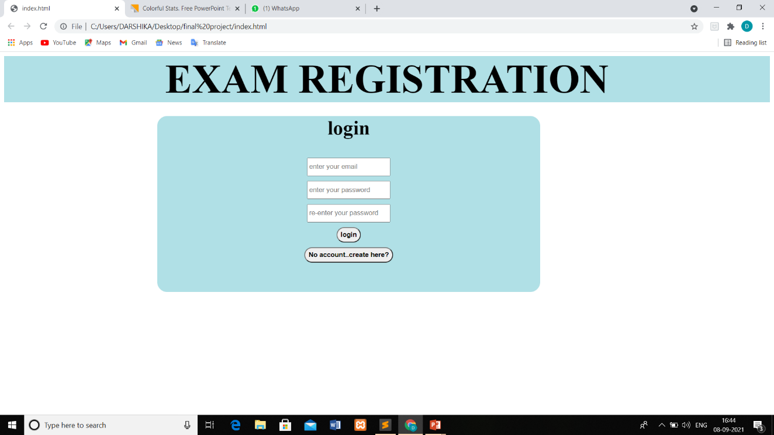

**Fig 7.1: Login**

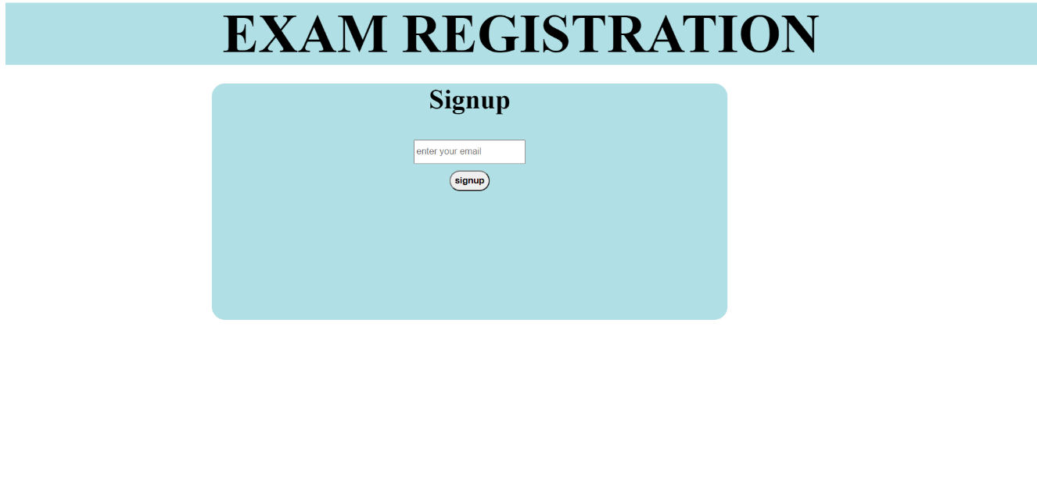

**Fig 7.2 Signup:**

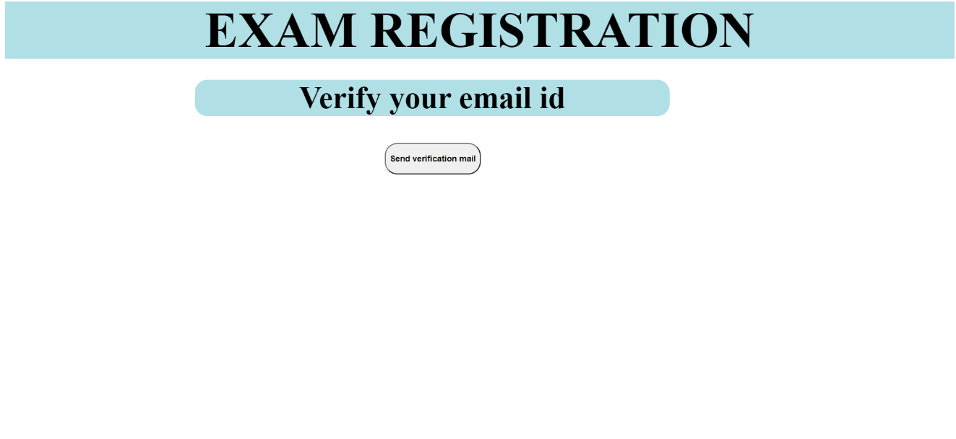 **Fig 7.3: Verification Page**

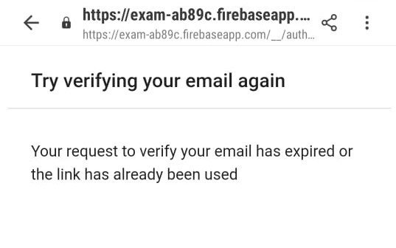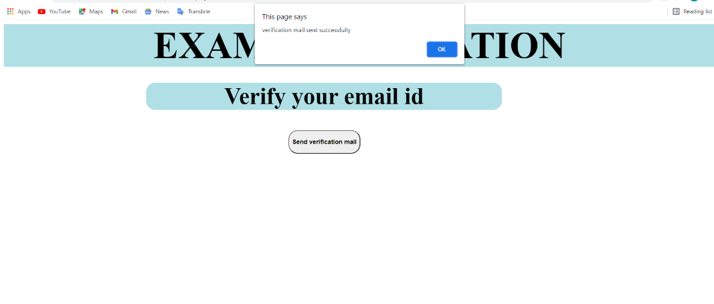

**Fig 7.4: EMAIL AUTHENTICACTION process**

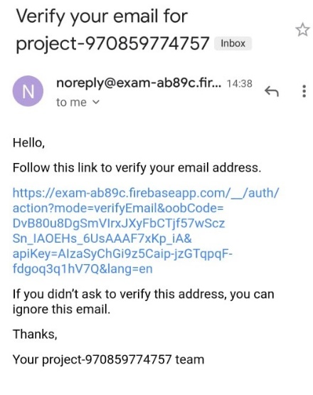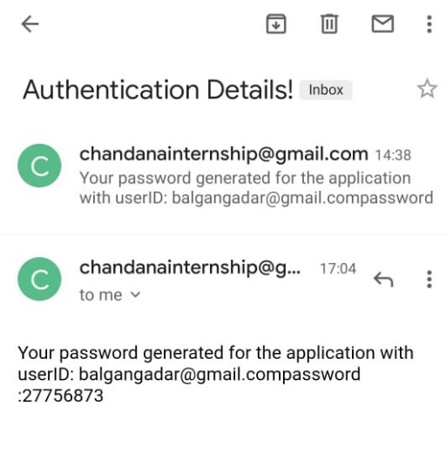

**Fig 7.4: EMAIL AUTHENTICACTION process**

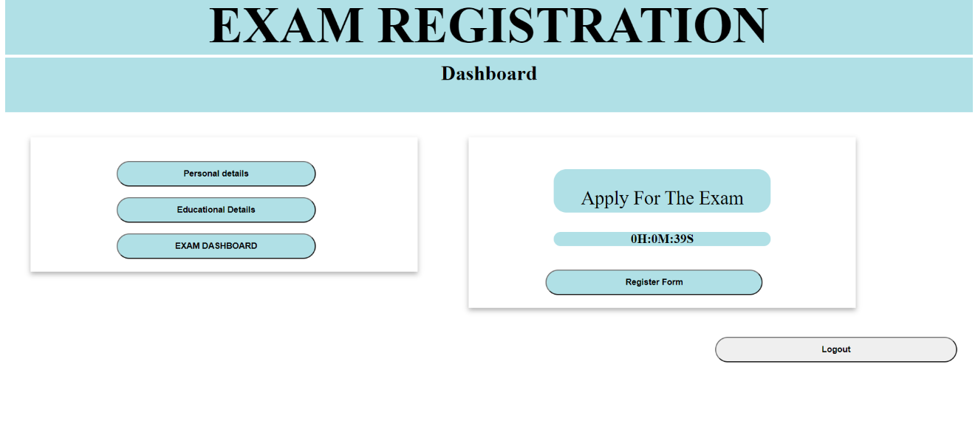

**Fig 7.5: Dashboard**

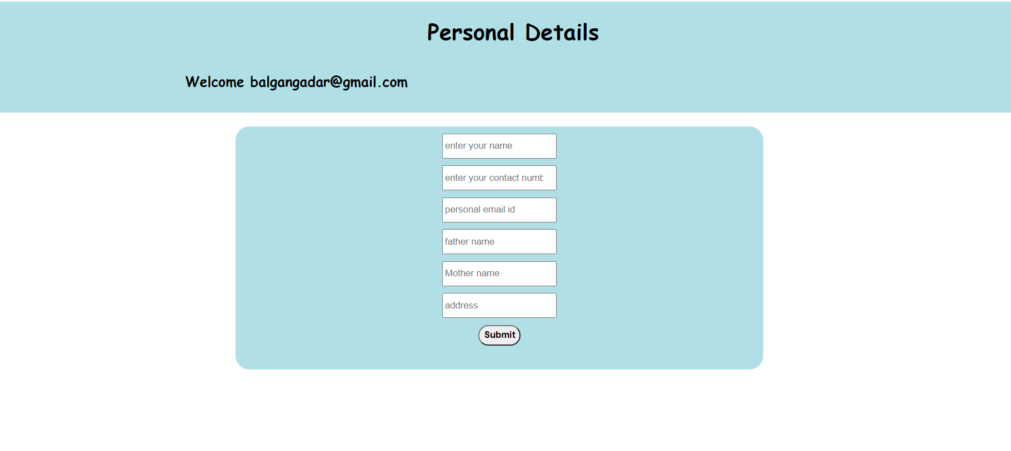

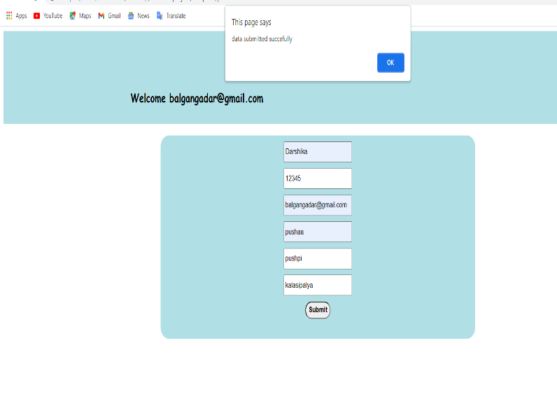

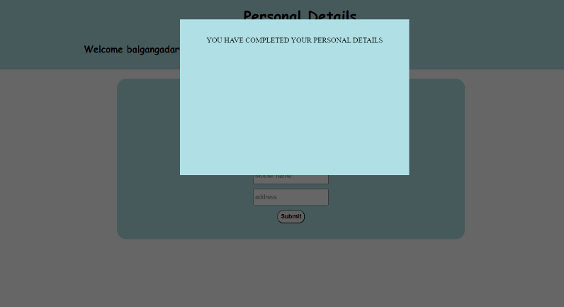

**Fig 7.6: Personal Details**

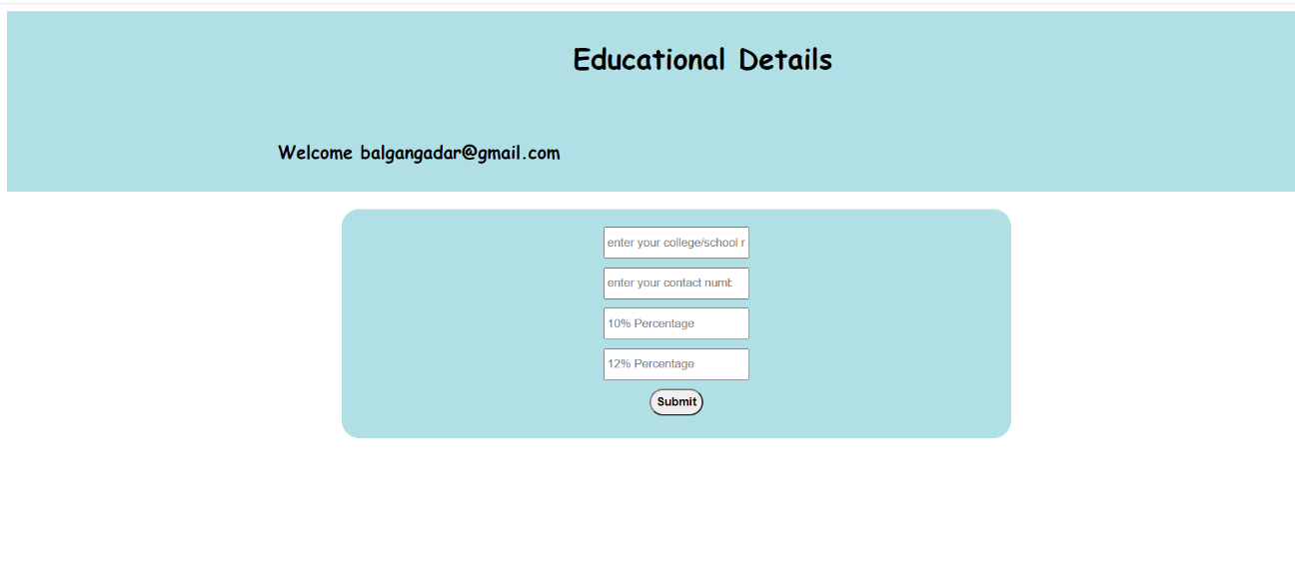

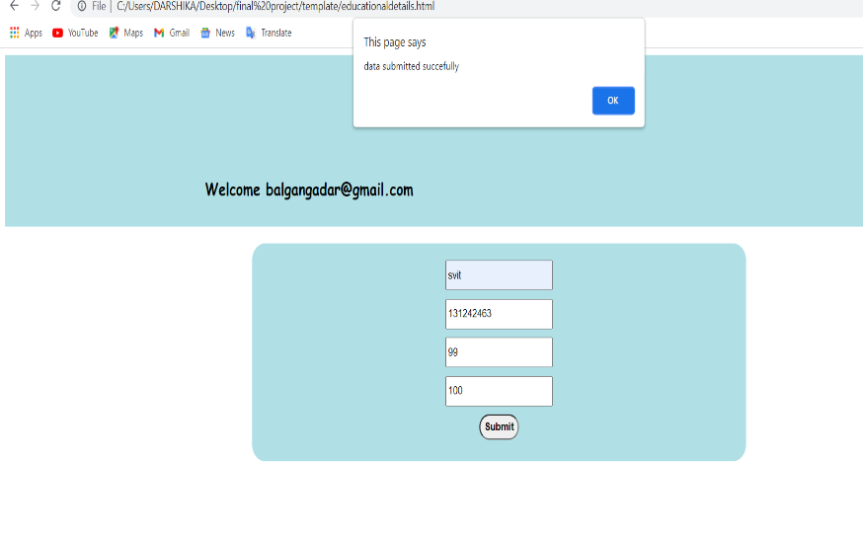

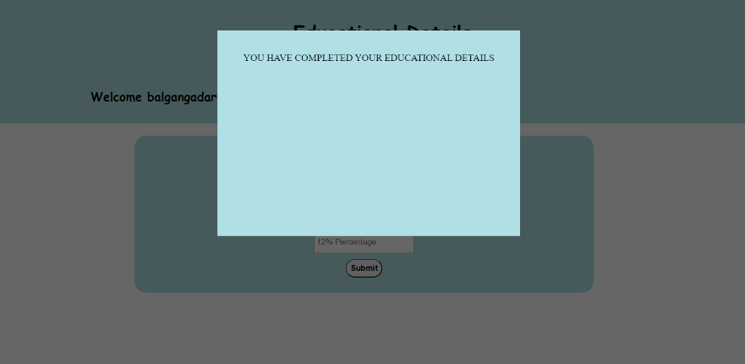

**Fig 7.7: Educational Details**



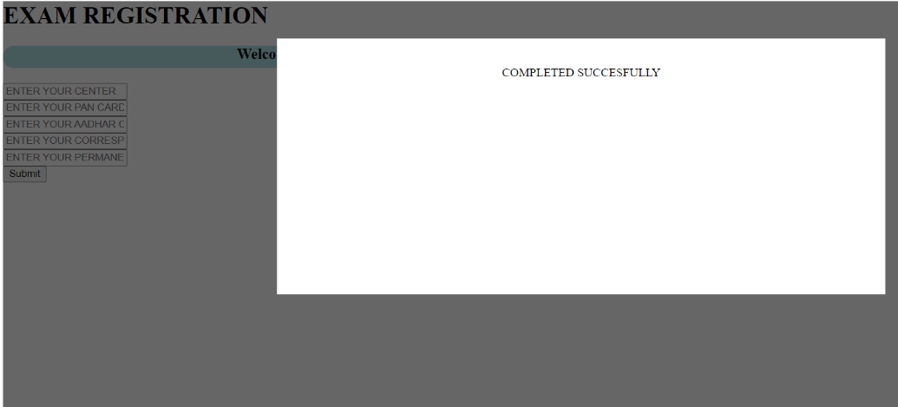

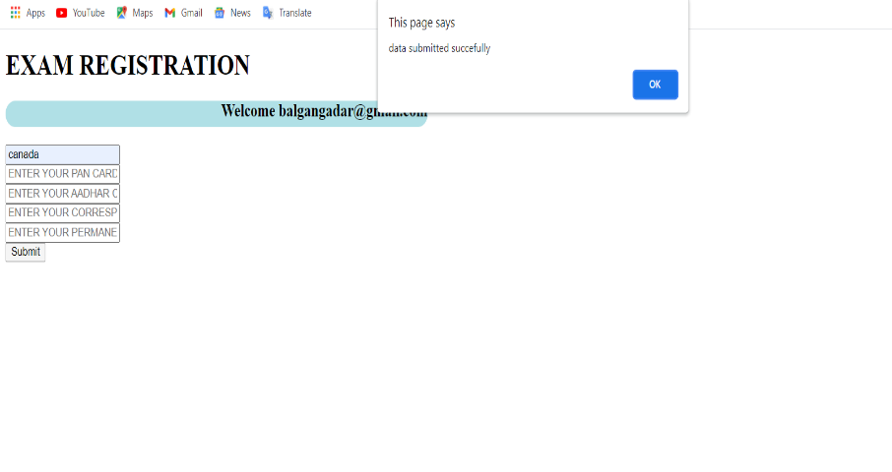

**Fig 7.8: Exam Registration**

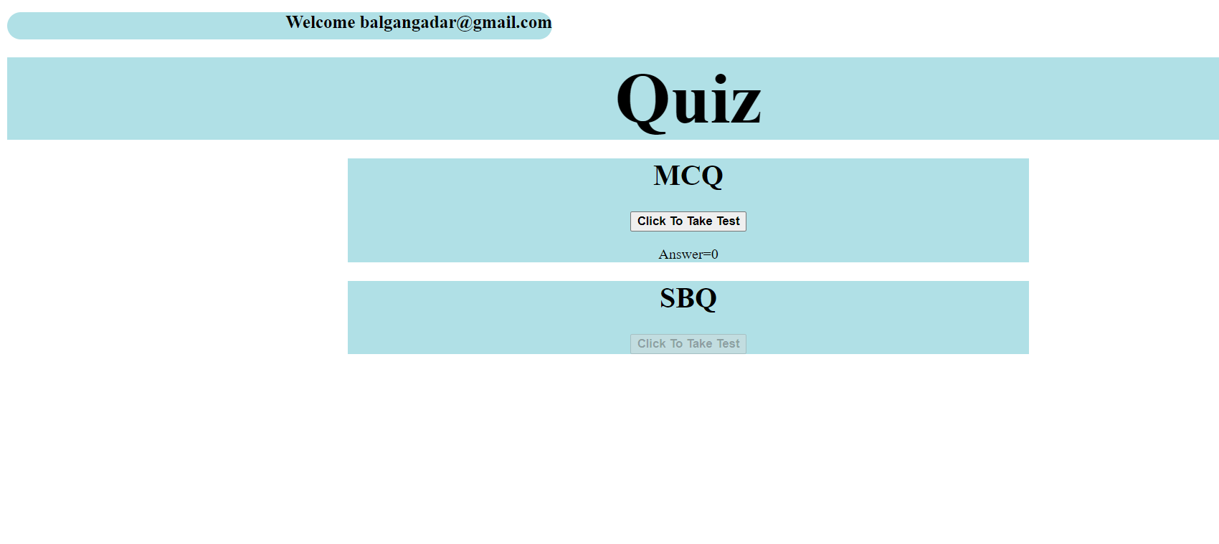

**Fig 7.9: Exam Dashboard**

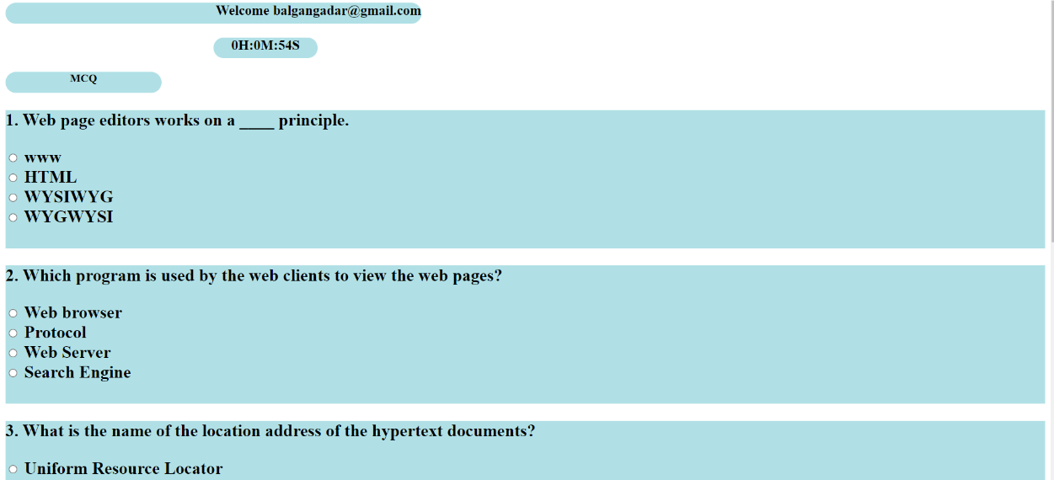



**Fig 7.10: MCQ**

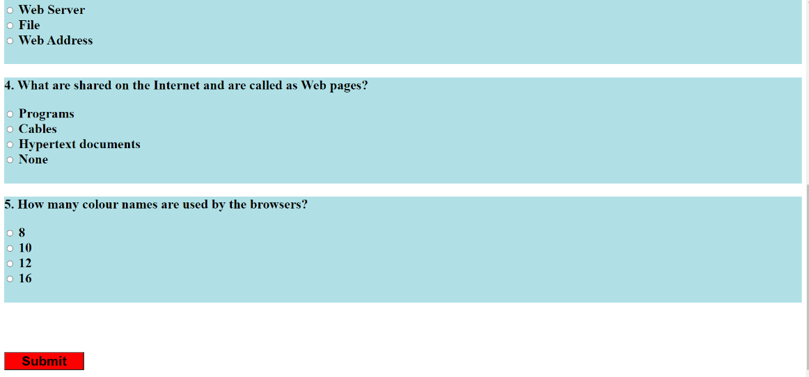

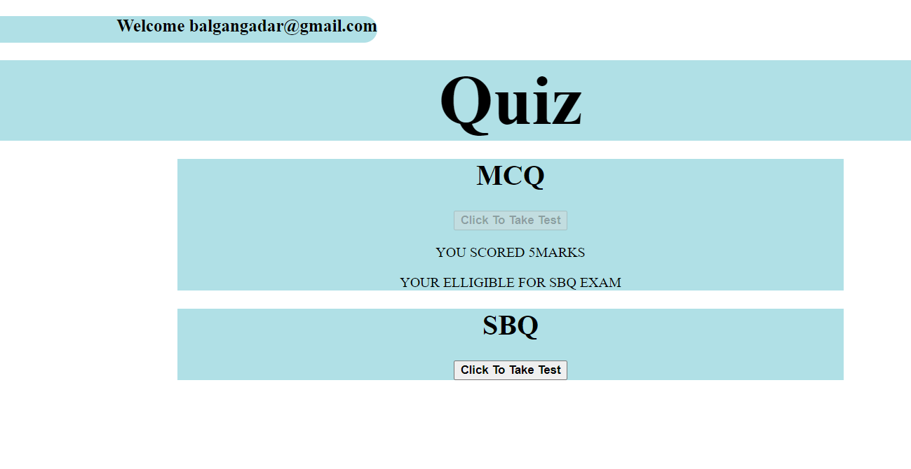

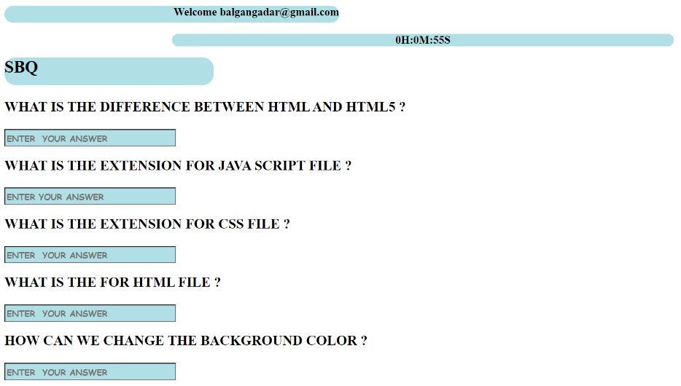

**Fig 7.11: SBQ(AFTER QUALIFYING MCQ TEST & MARKS OF MCQ DISPLAYED)**

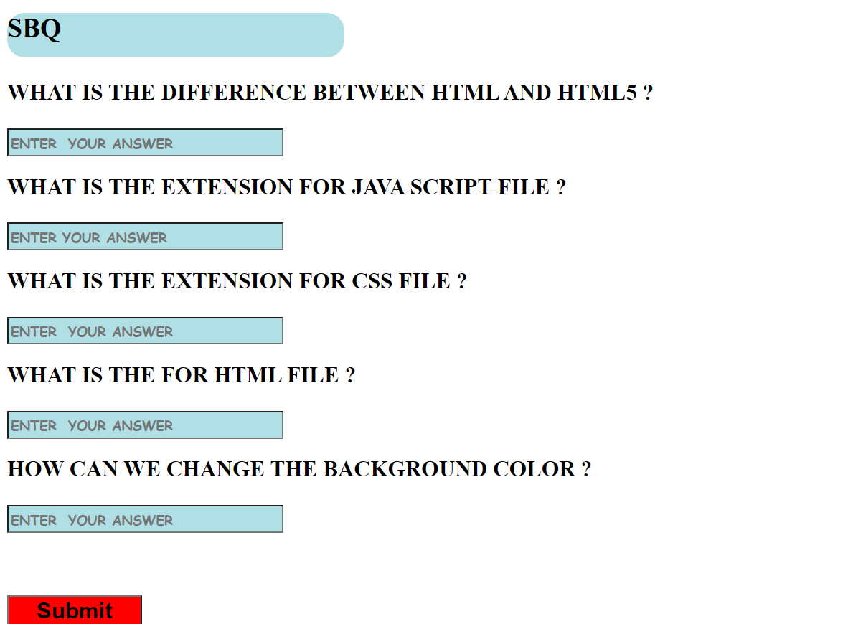

**REFERENCES**

1. https:// www.zlearn.in
2. https://www.tutorialspoint.com
3. https://www.geeksforgeeks.org
4. https://www.stackoverflow.com
5. https://www.javascript.com
6. https://www.youtube.com
7. https://www.mysql.com